


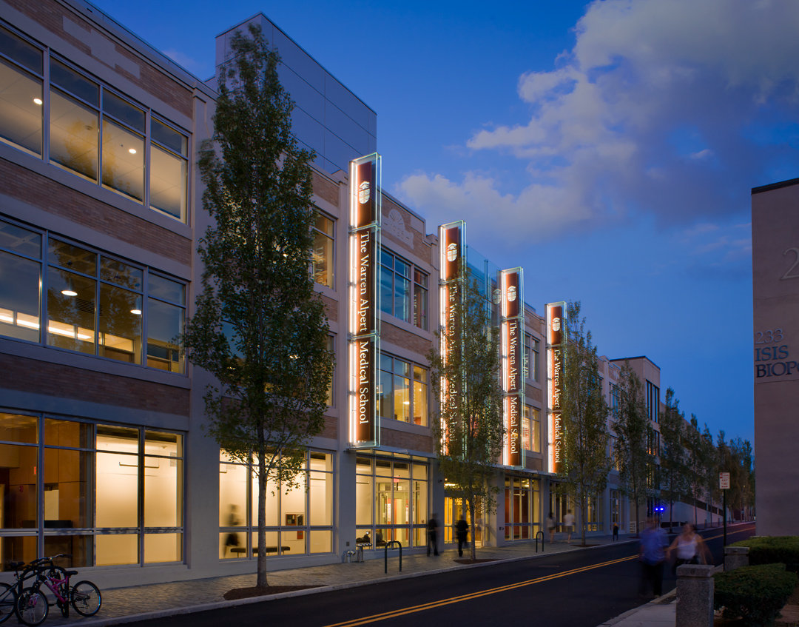
Pathology Grand Rounds

Topic: Intestinal Barriers. The Good, the Bad, and the Rehabilitated

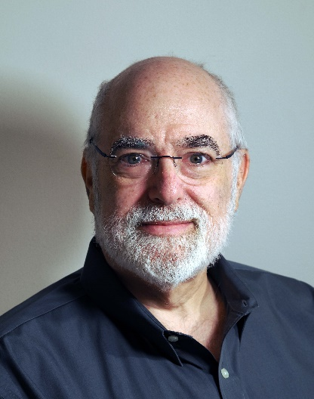
Date: May 29, 2025

Time: Lecture - 4:00-5:00 PM
Cocktail Reception - 5:00-6:00 PM

Location: Warren Alpert Medical School | Room 280 – Lecture
2nd Floor Commons - Cocktail Reception

Speaker: Jerrold R. Turner, MD, PhD
Professor of Pathology and Medicine
Brigham and Women's Hospital
Harvard Medical School
There is no fee to attend however pre-registration is required.
Please register prior to the session here:
CME Registration
Please Note: Faculty are expected to attend a minimum of 50% of Grand Rounds.

Accreditation: The Warren Alpert Medical School of Brown University is accredited by the Accreditation Council for Continuing Medical Education to provide continuing medical education for physicians.

Credit Designation:

Physicians: Alpert Medical School designates this live activity for a maximum of 1.0 AMA PRA Category 1 Credits TM. Physicians should claim only the credit commensurate with the extent of their participation in this activity.

Others: Upon request, participants will receive a certificate of attendance.

Disclosure: In accordance with the disclosure policy of the Warren Alpert Medical School, Brown University as well as standards set forth by the Accreditation Council for Continuing Medical Education, all those in a position to control the content of a CME presentation must disclose all financial relationships within the past twelve months with ineligible companies. Disclosures are reviewed and mitigated by the Brown CME Office if necessary.

